**BUSINESS REQUIREMENT DOCUMENT** Q&A PLATFORM FOR UNIVERSITY OF CAMBRIDGE

1. DOCUMENT VERSION

|  |  |  |  |
| --- | --- | --- | --- |
| **DATE** | **VERSION NO** | **CHANGES** | **DONE BY** |
| 23/10/2024 | 1012 | Adding button | Shreya Gore |
| 23/11/2024 | 1013 | Added new doc | Shreya Gore |

1. APPROVERS

|  |  |  |  |  |
| --- | --- | --- | --- | --- |
| **DATE** | **VERSION NO** | **APPROVER** | **SECTION** | **STATUS** |
| 23/10/2024 | 1012 | Pratik | FR004 | Approved |
| 23/11/2024 | 1013 | Pratik | FR006 | Approved |

1. PROJECT OBJECTIVE

The objective of this project is to design and implement a **Q&A Platform** for Cambridge University, enhancing communication between students and professors. The platform will facilitate a collaborative academic environment where students can post questions, including the option to do so **anonymously**, encouraging every student to actively participate. Professors will be able to provide detailed answers and create **polls** to gather student opinions or conduct quick surveys for engagement and feedback.

This project aims to improve academic communication by offering an intuitive and secure platform. It will serve as a hub for interactive learning, enhancing collaboration and enriching the educational experience for both students and faculty.

1. STAKEHOLDERS AND THEIR ROLES

|  |  |  |  |  |
| --- | --- | --- | --- | --- |
| **NAME** | **DESIGNATION** | **EXTERNAL AGENT** | **SIGN OFF AUTHORITY** | **NOTES** |
| Pratik | Executive Director | No | Yes | Wants Q&A platform working on the university website. |
| Shweta | Product Manager | No | No | Responsible for the product vision and make sure the project is on track and aligned with the product vision. |
| Shreya | Business analyst | No | No | Interaction with Prof, students, top management, Gathering Requirements, converting non technical requirements into technical req, Documentation. |
| Amol | Developer | No | No | Platform development, coding |
| Anuja | Tester | No | No | Quality testing |

1. PROJECT SCOPE

**5. 1 IN SCOPE:**

This Q&A platform will have all the below mentioned features:

|  |  |
| --- | --- |
| **SR. NO.** | **IN SCOPE FEATURES** |
| 1. | Students can post Questions, Post their comments on on-going discussions |
| 2. | Professors can create a poll, Post questions, Resolve student’s queries |
| 3. | Option to post anonymously |
| 4. | LaTex editor feature while drafting a post which will enable code blocking, equation writing, include images, videos. |
| 5. | Apply filters on posts- Unread, Read, Solved, Unsolved, Most recent (Updated) |
| 6. | Individual Q&A platform for each course/subject/module |

**5.2 OUT OF SCOPE:**

This project is limited with above mentioned features and will not support below features in this phase of the project.

|  |  |
| --- | --- |
| **SR. NO.** | **OUT OF SCOPE FEATURES** |
| 1. | Content will not be accessible/visible offline. |
| 2. | Platform will not allow casual discussions/non-academic discussion allowed on this platform. |
| 3. | External vendors will not be granted access to post anything or advertise on this platform. |
| 4. | Alumni will not have access to this platform. |

1. AVAILABLE RESOURCES:

For the development of this project, we have enough resources to fulfill all the client requirements. It includes human resources(strong technical teams), software, and hardware resources. All the detailed available resources are mentioned below:

|  |  |
| --- | --- |
| **RESOURCES** | **NOTES** |
| Strong BA & Product manager Team | Coordinating with stakeholders, converting nontechnical to tech req. |
| Development team | Coding, website development |
| Software | Figma- Designing  Lucidcharts- Flowcharts  Angular,HTML, CSS, Javascript- Front End development  Node.js- Backend development  MySQL- Database  AWS- Hosting |
| Hardware | Computers, laptops, Mobile, Printer, Fax machine |
| Documentation/Templates | MS Word, Excel, Google docs, Canva |

1. CONSTRAINTS:

In this project, our team will have to face some limitations and those are mentioned below:

TIME: This project will be delivered within 6 months of timeline and the project cannot be delivered before that. The timeline has been finalized based on the requirements of our team and workflow of the project.

BUDGET: Total estimated budget for this project is $90,000. The budget would be more depending on the software. The total cost of the daily operations will remain unchanged. However, in certain cases, cost may vary according to the change in economy.

RESOURCE AVAILABILITY: Development is limited by the availability of key personnel, including developers, UI/UX designers, and testers.

The reliance on existing IT staff for integration with university systems may lead to scheduling conflicts with other ongoing projects.

QUALITY: We will ensure to deliver the platform with no errors, bugs or any kind of internet virus. There could be some exceptions like online traffic and loading problems.

RISK: Potentially, there will not be a risk factor throughout the project lifeline. In certain cases, if there comes a problem, it will affect the project deadline.

CUSTOMER SATISFACTION: We will deliver the product aligned with the client requirements within the given timeline and budget. After delivering the project, if there comes an issue, our maintenance team will be available to resolve it.

1. LIST OF ASSUMPTIONS:

|  |  |
| --- | --- |
| **ASSUMPTIONS** | **ACTIVITIES** |
| Resources | * All the resources and equipment needed for the project will be obtained and available throughout the project. * All the resources, softwares, materials and equipment will be available in a good condition throughout the project. |
| Team | * All the people involved and related to the project will be available everyday however, there are exceptions of health conditions, sudden unexpected situations, illness etc. * All the people involved at the beginning of the project will remain throughout the project until the project is delivered; however, it is crucial to take note that employees can withdraw from the project at any time throughout the lifetime of the project. |
| Cost | * The cost spent will not exceed the actual planned budget. However, if the resources depreciate or malfunction, the actual cost will exceed the actual planned cost by the Project manager. * The purchase cost of materials, equipment, hardware, software will remain unchanged. However, the market price will change. |
| Access and authentication | * Users will have access to the platform through the university's SSO login credentials. * External users and vendors will not have access to this platform unless approved explicitly. |
| User behavior | * Students and faculty will actively engage with the platform, ensuring its adoption and effectiveness. |
| Training and Support | * Training sessions for faculty and students on using the platform will be conducted post-deployment. * A dedicated support team will be available for addressing user issues during the initial rollout phase. |

1. REQUIREMENTS

9.1 BUSINESS REQUIREMENTS

* Business requirements articulate the purpose and value this platform will bring to Cambridge University, ensuring alignment with its academic goals.
* **Purpose**: To create a centralized Q&A platform to enhance collaboration between students and professors across different courses and modules, fostering an engaging academic environment.
* **Value**: This platform will drive academic excellence by streamlining communication, improving feedback loops, and promoting an inclusive learning culture.

|  |  |  |  |  |  |  |
| --- | --- | --- | --- | --- | --- | --- |
| **Req ID** | **Requirement Name** | **Requirement Description** | **Priority** | **Acceptance Criteria** | **Dependencies** | **Assumptions** |
| **BR-001** | Enhance Collaboration | The platform must enhance communication and collaboration between students and professors. | Must-Have | Students and professors must confirm an increase in engagement during a post-launch survey. | University IT infrastructure | Users have internet access. |
| **BR-002** | Enable Student Interaction | Enable students to post questions and comments for interactive discussions. | Must-Have | Students can successfully post and view their questions and comments in relevant course modules. | Functional UI for Q&A posting | Students understand platform basics. |
| **BR-003** | Facilitate Professor Engagement | Professors must be able to resolve queries, post questions, and conduct polls or surveys. | Must-Have | Professors can create polls and post questions visible to their students in a specific course module. | Poll creation functionality | Professors adopt the platform. |
| **BR-004** | Anonymous Posting | Students must have the option to post questions anonymously. | Should-Have | Students can toggle an anonymity option before posting, and their identity remains hidden if selected. | UI toggle for anonymity | Anonymity does not affect moderation. |
| **BR-005** | Course-Specific Spaces | Each course/module must have a separate Q&A space to ensure focused discussions. | Must-Have | Each course page has a distinct and accessible Q&A section with no cross-course data leakage. | Data segregation mechanism | Course data is provided beforehand. |
| **BR-006** | Secure Platform | Ensure secure access and protect user data as per university policies. | Must-Have | Platform must comply with Cambridge's security policies and pass penetration testing. | University authentication system | Users agree to platform policies. |

9.2 STAKEHOLDER REQUIREMENTS

Stakeholder requirements focus on the specific needs of the key stakeholders of the platform: students, professors, and university administrators.

|  |  |  |  |  |  |  |
| --- | --- | --- | --- | --- | --- | --- |
| **Req ID** | **Requirement Name** | **Requirement Description** | **Stakeholder** | **Acceptance Criteria** | **Dependencies** | **Assumptions** |
| **SR-001** | Student Posting Capability | Students must be able to post questions and comments. | Students | Students can post and edit questions within the platform and see responses in real time. | User interface development | Students will regularly engage. |
| **SR-002** | Professor Query Resolution | Professors must provide detailed responses to queries. | Professors | Professors can reply to questions, mark them as resolved, and post follow-ups. | Q&A tracking system | Professors are responsive. |
| **SR-003** | Post Filters | Students must be able to filter posts by status (Unread, Solved, etc.). | Students | Filters such as “Unread” and “Solved” can be applied without errors to refine results. | Filter logic and metadata tagging | Filters are intuitive to use. |
| **SR-004** | Poll Creation | Professors must create polls and surveys to gather feedback. | Professors | Professors can create polls with at least three options and see aggregated results. | Polling functionality | Students participate in polls. |
| **SR-005** | Usage Analytics | University administration must monitor platform usage for compliance. | Administration | Usage metrics (e.g., active users, questions asked) must be viewable by the administration in dashboards. | Reporting and analytics features | Reporting will be lightweight initially. |

9.3 SOLUTION REQUIREMENTS

9.3.1 FUNCTIONAL REQUIREMENTS

Functional requirements define the platform's features and functionalities. Functional requirements of this project are listed as below:

|  |  |  |  |  |  |  |
| --- | --- | --- | --- | --- | --- | --- |
| **Req ID** | **Requirement Name** | **Requirement Description** | **Priority** | **Acceptance Criteria** | **Dependencies** | **Assumptions** |
| **FR-001** | Real-Time Posting | Enable students to post questions and comments in real-time. | Must-Have | Students can post questions and comments without delays, and posts are visible to all relevant users. | Real-time database updates | No concurrent posting issues. |
| **FR-002** | Anonymity Option | Allow students to post anonymously. | Should-Have | Anonymity toggle works seamlessly without disclosing student details to peers or professors. | Anonymity logic | Professors can see anonymized data for moderation. |
| **FR-003** | Poll Management | Professors can create and manage polls. | Should-Have | Professors can add, edit, and delete polls, and students can vote with real-time updates on results. | Poll design module | Polls support up to 5 response options. |
| **FR-004** | Post Filters | Implement filters (Unread, Solved, Unsolved, Most Recent). | Must-Have | Filters work across posts, showing only relevant results, and users can combine multiple filters. | Database query optimization | Filters are visually intuitive. |
| **FR-005** | LaTeX Editor | Include a LaTeX editor for equations, images, and videos. | Must-Have | Students and professors can format posts using LaTeX, preview them before submission, and attach media. | LaTeX parser and rendering engine | Users are familiar with LaTeX basics. |
| **FR-006** | Individual Course Sections | Ensure individualized Q&A sections for each course/module. | Must-Have | Each course/module has a separate Q&A page with access limited to enrolled students and professors. | Course enrollment data | Accurate enrollment information is available. |
| **FR-007** | Role-Based Access Control | Provide secure login and role-based access control. | Must-Have | Only authenticated users can access the platform, with restricted permissions based on their roles. | University SSO system | Authentication system is robust. |

9.3.2 NON FUNCTIONAL REQUIREMENTS

|  |  |  |  |  |  |  |
| --- | --- | --- | --- | --- | --- | --- |
| **Req ID** | **Requirement Name** | **Requirement Description** | **Priority** | **Acceptance Criteria** | **Dependencies** | **Assumptions** |
| **NFR-001** | User-Friendly Interface | The platform must have a user-friendly interface. | Must-Have | Usability testing shows 90% of users can complete core tasks without guidance. | UX/UI design standards | Users provide feedback for improvement. |
| **NFR-002** | Scalability | The system must support up to 10,000 concurrent users. | Must-Have | Performance testing confirms stable operation under load conditions. | Scalable infrastructure | Traffic will vary by semester timing. |

9.4 TRANSITION REQUIREMENTS

Transition requirements address the steps for implementing and adopting the new platform. Transition requirements are listed below.

|  |  |  |  |  |  |  |
| --- | --- | --- | --- | --- | --- | --- |
| **Req ID** | **Requirement Name** | **Requirement Description** | **Priority** | **Acceptance Criteria** | **Dependencies** | **Assumptions** |
| **TR-001** | Data Migration | Migrate initial course/module data and user accounts from existing systems. | High | All existing data is migrated accurately, with user roles and permissions intact. | Access to legacy systems | Legacy system data is complete. |
| TR-002 | User Training | Provide training sessions for students and professors on platform use. | Medium | 80% of users attend training sessions, and satisfaction surveys show positive feedback. | Training content development | Trainers are familiar with the platform. |
| TR-003 | Help Resources | Develop a user manual and help resources for platform guidance. | Medium | Manuals and tutorials are made available in the Help section, covering all major functionalities. | Documentation team involvement | Users refer to guides for self-help. |
| TR-004 | Feedback Mechanism | Establish a feedback mechanism for reporting issues during the transition. | Medium | Users can submit feedback directly via the platform, and issues are logged for review. | Feedback collection tool | Users provide detailed and actionable feedback. |

1. USE-CASE DIAGRAM

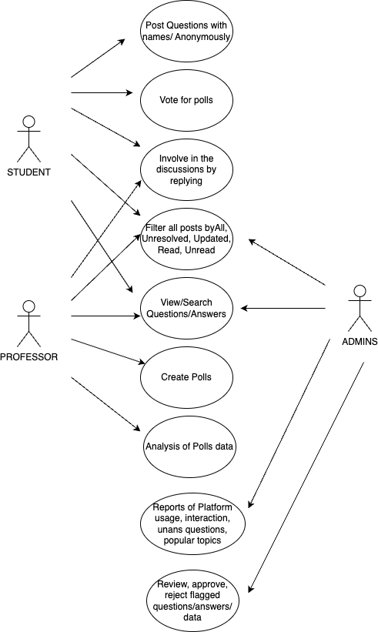

10.1 USE CASE TEMPLATE:

**Use Case: Post a Question**

|  |  |
| --- | --- |
| **Use Case ID** | **UC001** |
| **Use Case Name** | Post a Question |
| **Actors** | Student, System |
| **Description** | Students can post questions on the platform with or without displaying their name. |
| **Preconditions** | The student must be logged in using SSO credentials. |
| **Postconditions** | The question is successfully posted, and notifications are sent to professors and students. |
| **Frequency of Use** | Multiple times a day |
| **Main Course** | 1. User logs in.  2. User clicks on "Post a Question."  3. User fills in details and submits. |
| **Alternate Course** | 1. User retries if initial login fails.  2. User chooses to post anonymously or with their name. |
| **Exception Course** | 1. Network issues prevent login or question posting. |

**Use Case: Answer a Question**

|  |  |
| --- | --- |
| **Use Case ID** | **UC002** |
| **Use Case Name** | Answer a Question |
| **Actors** | Professor, System |
| **Description** | Professors provide answers to questions posted by students. |
| **Preconditions** | The professor must be logged in, and there must be at least one question available to answer. |
| **Postconditions** | The answer is successfully posted and visible to all users. |
| **Frequency of Use** | Multiple times a day |
| **Main Course** | 1. User logs in.  2. User selects a question to answer.  3. User provides the answer and submits. |
| **Alternate Course** | 1. User retries if initial login fails.  2. User skips answering and selects another question if needed. |
| **Exception Course** | 1. Network issues prevent login or answering the question. |

**Use Case: Vote on a Poll**

|  |  |
| --- | --- |
| **Use Case ID** | **UC003** |
| **Use Case Name** | Vote on a Poll |
| **Actors** | Student, Professor |
| **Description** | Users can participate in polls created by professors. |
| **Preconditions** | A poll must be created and open for voting. |
| **Postconditions** | The vote is successfully recorded. |
| **Frequency of Use** | Multiple times a day |
| **Main Course** | 1. User logs in.  2. User votes on the desired poll option. |
| **Alternate Course** | 1. User retries if initial login fails.  2. User skips voting on a poll if they don’t wish to participate. |
| **Exception Course** | 1. Network issues prevent login or submitting votes. |

**Use Case: Create a Poll**

|  |  |
| --- | --- |
| **Use Case ID** | **UC004** |
| **Use Case Name** | Create a Poll |
| **Actors** | Professor, System |
| **Description** | Professors create polls to engage students or gather feedback. |
| **Preconditions** | The professor must be logged into the platform. |
| **Postconditions** | The poll is created and visible to all users. |
| **Frequency of Use** | Occasionally (as per course schedule or specific needs) |
| **Main Course** | 1. User logs in.  2. User creates a poll with questions and options. |
| **Alternate Course** | 1. User retries if initial login fails.  2. User edits the poll before submitting. |
| **Exception Course** | 1. Network issues prevent login or creating polls. |

**Use Case: Moderate Content**

|  |  |
| --- | --- |
| **Use Case ID** | **UC005** |
| **Use Case Name** | Moderate Content |
| **Actors** | Administrator, System |
| **Description** | Administrators review, approve, or reject flagged content. |
| **Preconditions** | The administrator must be logged in, and content must be flagged. |
| **Postconditions** | The flagged content is reviewed, and the system reflects the updated status (approved, rejected, or edited). |
| **Frequency of Use** | Occasionally (whenever flagged content is submitted) |
| **Main Course** | 1. User logs in.  2. User reviews flagged content and takes action. |
| **Alternate Course** | 1. User retries if initial login fails.  2. Admin defers decision for further review. |
| **Exception Course** | 1. Network issues prevent login or moderating flagged content. |

**Use Case: Filter Posts**

|  |  |
| --- | --- |
| **Use Case ID** | **UC006** |
| **Use Case Name** | Filter Posts |
| **Actors** | Student, Professor |
| **Description** | Users can filter posts based on various categories: All, Unresolved, Updated, Read, and Unread. |
| **Preconditions** | The user must be logged in to access the filtering options. |
| **Postconditions** | The filtered posts are displayed according to the selected category. |
| **Frequency of Use** | Multiple times a day |
| **Main Course** | 1. User logs in.  2. User selects a filter category.  3. The system displays relevant posts. |
| **Alternate Course** | 1. User retries if initial login fails.  2. User switches between filters as required. |
| **Exception Course** | 1. Network issues prevent login or accessing filtering options. |

**Use Case: Analyze Poll Data**

|  |  |
| --- | --- |
| **Use Case ID** | **UC007** |
| **Use Case Name** | Analyze Poll Data |
| **Actors** | Professor |
| **Description** | Professors can analyze poll responses to assess student engagement and feedback. |
| **Preconditions** | Poll data must exist, and the professor must be logged in. |
| **Postconditions** | Poll results are analyzed and insights are generated. |
| **Frequency of Use** | Occasionally (after poll completion) |
| **Main Course** | 1. User logs in.  2. User selects the poll to analyze.  3. System displays poll insights. |
| **Alternate Course** | 1. User retries if initial login fails.  2. User exports the poll results for offline analysis. |
| **Exception Course** | 1. Poll results are unavailable due to system issues. |

**Use Case: View/Search Questions and Answers**

|  |  |
| --- | --- |
| **Use Case ID** | **UC008** |
| **Use Case Name** | View/Search Questions and Answers |
| **Actors** | Student, Professor, Administrator |
| **Description** | Users can view or search for specific questions and answers on the platform. |
| **Preconditions** | The user must be logged in. |
| **Postconditions** | The desired question or answer is displayed. |
| **Frequency of Use** | Multiple times a day |
| **Main Course** | 1. User logs in.  2. User enters a keyword in the search bar or browses the list of questions/answers. |
| **Alternate Course** | 1. User retries if initial login fails.  2. User refines the search for better results. |
| **Exception Course** | 1. Search fails due to system errors or lack of relevant data. |

**Use Case: Generate Reports**

|  |  |
| --- | --- |
| **Use Case ID** | **UC009** |
| **Use Case Name** | Generate Reports |
| **Actors** | Administrator |
| **Description** | Administrators can generate reports on platform usage, popular topics, unanswered questions, and user interactions. |
| **Preconditions** | The administrator must be logged in. |
| **Postconditions** | Reports are generated and available for download or viewing. |
| **Frequency of Use** | Periodically (e.g., weekly or monthly) |
| **Main Course** | 1. User logs in.  2. User selects the type of report to generate.  3. System generates and displays the report. |
| **Alternate Course** | 1. User retries if initial login fails.  2. User exports the report for offline use. |
| **Exception Course** | 1. Report generation fails due to system issues or data unavailability. |

**Use Case: Review Flagged Content**

|  |  |
| --- | --- |
| **Use Case ID** | **UC010** |
| **Use Case Name** | Review Flagged Content |
| **Actors** | Administrator |
| **Description** | Administrators review flagged questions or answers and approve, reject, or edit them. |
| **Preconditions** | The administrator must be logged in, and there must be flagged content. |
| **Postconditions** | Flagged content is reviewed, and the status is updated. |
| **Frequency of Use** | Occasionally (when flagged content is reported) |
| **Main Course** | 1. User logs in.  2. User reviews flagged content.  3. User approves, rejects, or edits the flagged content. |
| **Alternate Course** | 1. User retries if initial login fails.  2. User defers review for further consideration. |
| **Exception Course** | 1. Network issues prevent login or reviewing flagged content. |

1. SPECIFIC REQUIREMENTS

The Specific Requirements section details the functional and non-functional requirements necessary for the successful development and deployment of the Q&A platform. These requirements align with project objectives and stakeholder needs.

**11.1 Functional Requirements**

11.1.1 User Registration and Authentication

* Integration with Cambridge University's Single Sign-On (SSO) system for secure login.
* Role-based access:

Students: Post questions, participate in polls, and view answers.

Professors: Respond to questions, create polls, and moderate content.

Admins: Manage users, handle flagged content, and generate reports.

11.1.2 Question and Answer Functionality

* Ability for students to post questions under specific categories (e.g., subject, department).
* Option to post questions anonymously.
* Professors can provide answers, with the ability to edit or delete their responses.
* Threaded discussions for follow-up questions and comments.

11.1.3 Polls and Surveys

* Professors can create polls with single-choice or multiple-choice options.
* Students can participate in polls and view results.

11.1.4 Moderation Tools

* Automated content filtering for inappropriate language or flagged keywords.
* Professors and admins can review, approve, or reject flagged content.

11.1.5 Notification System

* Email and in-platform notifications for:
* New responses to questions.
* Participation reminders for polls.
* Alerts for flagged or moderated content.

11.1.6 Search and Navigation

* Search functionality to find questions by keywords, topics, or tags.
* Category-based browsing for easy navigation.

11.1.7 Reports and Analytics

* Admins can generate reports on platform usage, popular topics, and unanswered questions.
* Professors can view participation metrics for their respective categories.

**11.2. Non-Functional Requirements**

11.2.1 Performance

* The platform should support up to 5,000 concurrent users with minimal latency (<2 seconds response time).

11.2.2 Scalability

* System architecture should allow for future expansion, including additional features or higher user volume.

11.2.3 Security

* Data encryption for user credentials and sensitive information.
* Compliance with GDPR and university data policies.

11.2.4 Accessibility

* Adherence to WCAG 2.1 standards to ensure usability for students with disabilities.

11.2.5 Cross-Platform Compatibility

* The platform must function seamlessly across browsers (Chrome, Firefox, Safari) and devices (desktop, tablet, mobile).

11.2.6 Maintenance and Updates

* Provisions for regular updates to fix bugs, improve features, and enhance security.

1. BUSINESS PROCESS OVERVIEW

12.1 CURRENT PROCESS “AS-IS” BUSINESS ENVIRONMENT

### 

### **12.1.1 ANALYSIS OF AS-IS PROCESS MODEL**

#### **12.1.1.1 Current Process Overview**

The existing communication process between students and professors is segmented into multiple channels:

1. Email Communication: Students send queries via email, and professors reply individually.
2. Lecture-Based Interactions: Students ask questions during lectures, and professors address them in real-time.
3. One-on-One Meetings: Students book appointments for personal interaction with professors to discuss their queries.
4. Informal Discussions: Students rely on informal group chats and platforms for peer support and discussions.
5. Manual Surveys: Professors gather feedback or insights through class-based manual surveys.

#### **12.1.1.2 Key Observations and Pain Points**

1. Fragmented Communication Channels:
   * Multiple communication methods (email, lectures, appointments, informal platforms) result in inefficiencies and potential delays in addressing student queries.
   * There is no centralized system to track or consolidate all interactions.
2. Limited Anonymity:
   * Students may hesitate to ask questions in public settings, such as lectures or group chats, due to fear of judgment or embarrassment.
3. Lack of Collaboration:
   * There is minimal opportunity for collaborative learning among students and professors. Most discussions are one-on-one, limiting shared knowledge dissemination.
4. Inefficient Feedback Mechanisms:
   * Manual surveys conducted during classes are time-consuming and prone to bias or low participation rates. There is no digital mechanism for collecting or analyzing feedback efficiently.
5. Scalability Challenges:
   * The current model relies heavily on professors' availability, which may not scale effectively with larger student groups.
6. Dependency on Informal Platforms:
   * Reliance on external informal platforms for discussions may lead to loss of context, lack of academic oversight, and potential data privacy issues.

#### 

#### **12.1.1.3 Impact of Current Limitations**

1. Student Experience:
   * Delays and inefficiencies in getting responses may discourage active participation and hinder academic growth.
   * Students preferring anonymity might refrain from asking questions altogether, affecting their learning.
2. Professor Workload:
   * Handling individual emails and one-on-one meetings increases the workload, leaving less time for academic preparation or research.
3. Collaboration and Learning:
   * The lack of a shared platform restricts collaborative problem-solving and shared understanding between students and faculty.
4. Institutional Challenges:
   * Manual surveys and fragmented communication channels hinder the university's ability to gather actionable insights for continuous improvement.

12.2 FUTURE PROCESS -“TO-BE” BUSINESS ENVIRONMENT

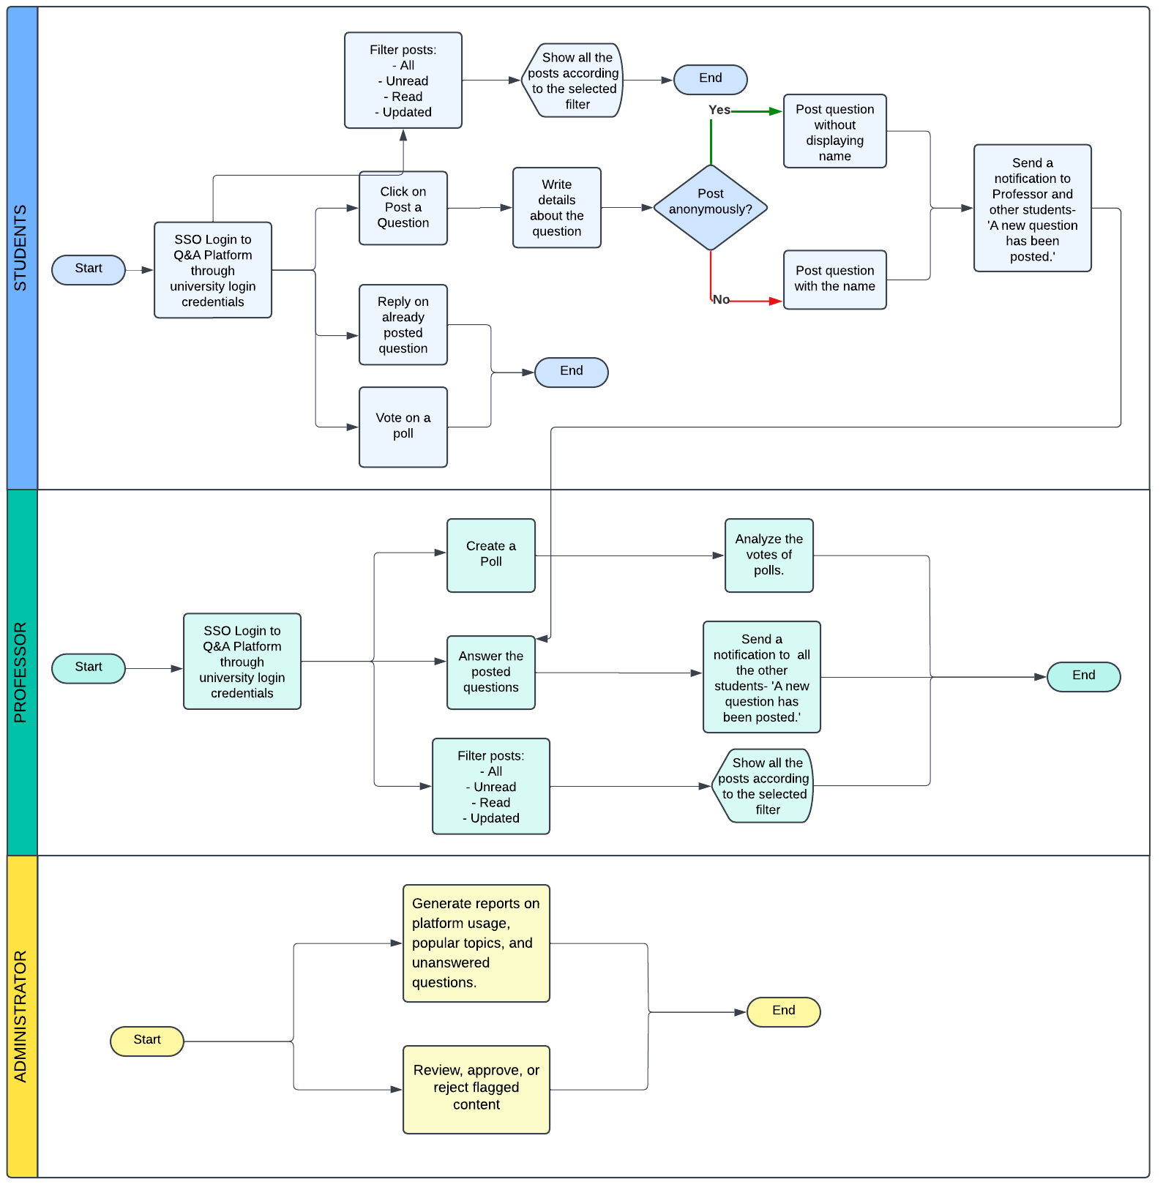

#### **12.2.1 Key Improvements Over AS-IS Process**

1. Centralization: All interactions occur on a single platform, eliminating the need for multiple fragmented communication methods.
2. Encouraged Participation: The option for anonymous posting ensures inclusivity and encourages students to ask questions freely.
3. Improved Collaboration: The platform fosters collaborative learning by enabling students and professors to engage in meaningful discussions and share knowledge collectively.
4. Automated Processes: Notifications, filtering systems, and reporting tools enhance efficiency for students, professors, and administrators.
5. Data-Driven Insights: Administrators can leverage analytics to optimize platform usage and academic support services.

#### **12.2.2 Future Workflow**

1. Students log in, post questions, and engage with polls or discussions using the platform.
2. Professors respond to questions, create polls, and analyze student feedback through the system.
3. Administrators monitor flagged content and generate insights through automated reporting tools.

13. USER STORIES

Here are the **user stories** along with their corresponding **acceptance criteria** in the **Given-When-Then** format:

### **User Story 1: Post Questions with Names/Anonymously**

* **As a student**, I want to post questions either with my name or anonymously so that I can ask questions comfortably without hesitation.

#### **Acceptance Criteria:**

1. **Given** the student is logged in to the Q&A platform,  
    **When** they choose to post a question with their name and submit it,  
    **Then** the question should display their name on the platform.
2. **Given** the student is logged in to the Q&A platform,  
    **When** they choose the "Post Anonymously" option and submit a question,  
    **Then** the question should be posted without showing their name.

### **User Story 2: Vote for Polls**

* **As a student**, I want to vote on polls so that I can express my opinion, contribute to the discussion, and provide feedback.

#### **Acceptance Criteria:**

1. **Given** a student is logged in and a poll is available,  
    **When** they select an option in the poll and confirm their choice,  
    **Then** the vote should be recorded and reflected in the poll results.
2. **Given** a professor has created a poll,  
    **When** students vote on the poll,  
    **Then** the system should update the poll analysis in real-time.

### **User Story 3: Involve in Discussions by Replying**

* **As a student**, I want to reply to questions or answers so that I can participate in discussions and clarify doubts.

#### **Acceptance Criteria:**

1. **Given** the student is logged in and views a question or answer,  
    **When** they write a reply and click "Submit,"  
    **Then** the reply should appear under the question or answer.
2. **Given** the discussion thread is open,  
    **When** a student replies to a post,  
    **Then** the system should notify the author of the post about the new reply.

### **User Story 4: Filter All Posts (All, Unresolved, Updated, Read, Unread)**

* **As a student or professor**, I want to filter posts by categories (All, Unresolved, Updated, Read, Unread) so that I can focus on specific types of posts.

#### **Acceptance Criteria:**

1. **Given** the user is logged in,  
    **When** they select a filter (e.g., "Unread"),  
    **Then** only the posts matching the selected filter should be displayed.
2. **Given** the user is viewing filtered posts,  
    **When** they update or mark a post as resolved,  
    **Then** the post should automatically move to the appropriate category (e.g., "Resolved").

### **User Story 5: View/Search Questions and Answers**

* **As a student or professor**, I want to search for specific questions or answers so that I can find relevant information quickly.

#### **Acceptance Criteria:**

1. **Given** the user is logged in,  
    **When** they enter keywords in the search bar and hit "Search,"  
    **Then** the system should display relevant questions and answers.
2. **Given** the user is viewing search results,  
    **When** they click on a result,  
    **Then** the system should display the full details of the selected question or answer.

### **User Story 6: Create Polls**

* **As a professor**, I want to create polls so that I can gather opinions or feedback from students.

#### **Acceptance Criteria:**

1. **Given** the professor is logged in,  
    **When** they navigate to the "Create Poll" section and define the poll question and options,  
    **Then** the system should save and publish the poll to the platform.
2. **Given** a poll is active,  
    **When** the professor sets an expiration date,  
    **Then** the poll should automatically close after the deadline passes.

### **User Story 7: Analyze Poll Data**

* **As a professor**, I want to analyze poll data so that I can understand students’ opinions or feedback trends.

#### **Acceptance Criteria:**

1. **Given** the professor has created a poll,  
    **When** the poll deadline is reached,  
    **Then** the system should generate a report summarizing the votes and trends.
2. **Given** the professor wants to analyze ongoing poll data,  
    **When** they view the poll results in real-time,  
    **Then** the system should display the current vote counts and percentages.

### **User Story 8: Review, Approve, or Reject Flagged Content**

* **As an admin**, I want to review flagged content and approve or reject it so that the platform maintains its integrity and quality.

#### **Acceptance Criteria:**

1. **Given** the admin is logged in and content has been flagged,  
    **When** they review the flagged post and choose "Approve,"  
    **Then** the content should be restored and visible on the platform.
2. **Given** the admin is logged in and content has been flagged,  
    **When** they review the flagged post and choose "Reject,"  
    **Then** the content should be removed from the platform permanently.
3. **Given** the admin has reviewed flagged content,  
    **When** they take action (approve or reject),  
    **Then** the system should log the action and notify the original poster.

14. PROTOTYPING

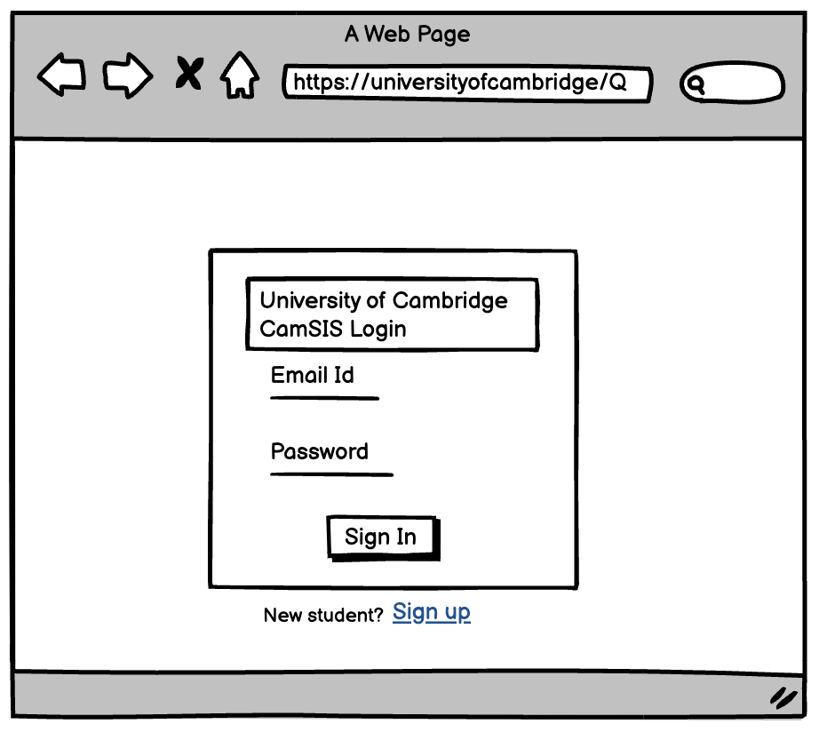

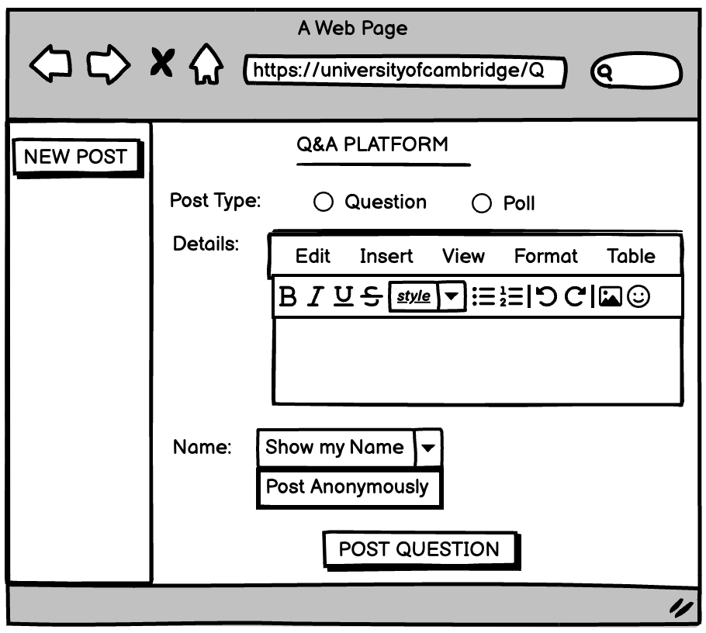

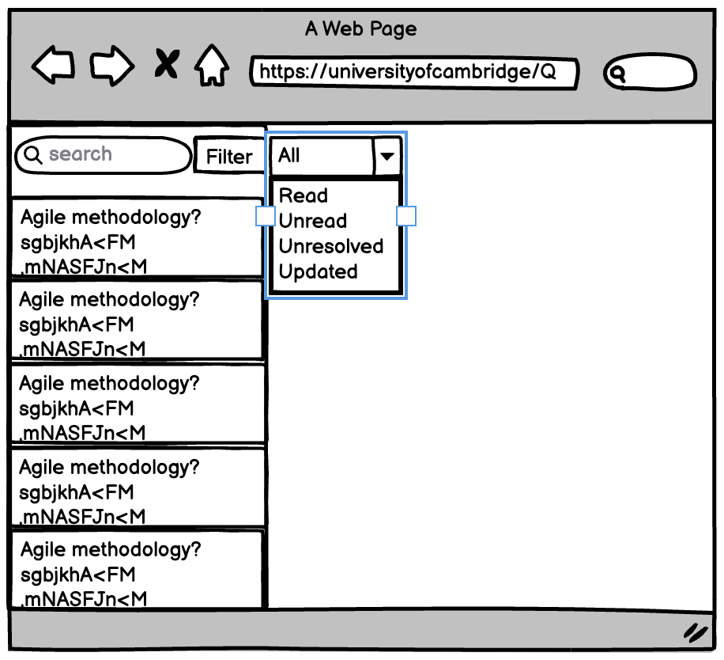

15. CONCLUSION

The **Q&A Platform** project is a critical initiative aimed at enhancing academic communication between students and professors at **Cambridge University**. The platform will serve as an interactive hub for students to post questions, engage with professors, and actively participate in academic discussions, thereby fostering a collaborative and inclusive learning environment. By incorporating features such as anonymous question submission, professor-led polls, and quick surveys, the platform aims to improve student engagement, increase participation, and provide professors with valuable feedback.

The requirements outlined in this **Business Requirements Document (BRD)** provide a clear and structured approach to the design, development, and implementation of the Q&A platform. The user stories, functional and non-functional requirements, and use case scenarios have been carefully defined to ensure that the platform meets both the business and technical goals. The platform will be developed with a focus on **usability**, **scalability**, and **security**, ensuring a seamless and efficient user experience for all stakeholders.

This document serves as a foundation for the subsequent phases of the project, including detailed design, development, and testing. The development process will be iterative, leveraging Agile methodology, ensuring flexibility and continuous improvement. As the platform evolves, we will continue to gather feedback from stakeholders and users to enhance its functionality and ensure its long-term success.

In conclusion, the **Q&A Platform** is a significant step forward in improving academic communication and providing a modern, engaging, and secure environment for learning and knowledge sharing. With clear objectives, well-defined requirements, and a collaborative approach to development, the project is poised for successful implementation and long-term impact on the academic community.